Measurements || Report: Optical Spectrum Analyzer

Name: Rania Hamada Mohammed

Section: 3

ID: 79

# Optical Spectrum Analyzer

It's basically an optical instrument. It measures properties of light over range of electromagnetic spectrum. The measured variable of OSA is usually light intensity. It can also be polarization state.

It is a precision instrument designed to measure and display the distribution of **power of an optical source over a specified wavelength span**.

An OSA trace **displays** wavelength (in µm or nm) in the horizontal scale and amplitude or power (in dB) in the vertical scale.

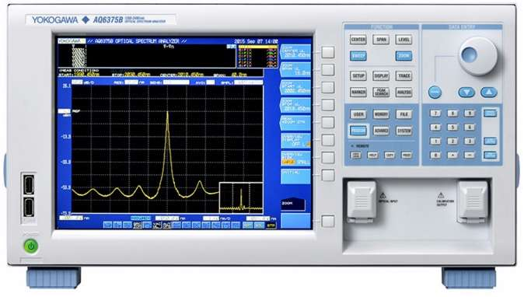The main application of OSA is to **troubleshoot problems in DWDM systems**.

Figure 1: DEPICTS OPTICAL SPECTRUM ANALYZER MODEL NUMBER AQ6375B FROM YOKOGAWA ELECTRIC CORPORATION.

## Optical Spectrum Analyzer Block DiagramBlock Diagram of Optical Spectrum Analyzer

Functions of OSA modules:

* Incoming optical signal to be measured is passed through wavelength tunable filter. This optical filter resolves different spectral components individually.
* Photodetector converts optical signal into electrical equivalent signal. This electrical current magnitude is proportional to incident optical power.
* The current is converted into equivalent voltage using transimpedance amplifier.
* Later this is digitized using ADC converter in the Optical Spectrum Analyzer. This signal is applied to vertical part of display unit as amplitude.
* Ramp tunes optical filter such that its resonant wavelength is proportional to horizontal position.

## Applications of OSA:

* Characterization of light sources such as lasers and light emitting diodes (LEDs)
* Testing of optical systems, for example wavelength division multiplexing systems in optical fiber communications networks, where one may need to test the optical powers of the different wavelength channels and measure signal-to-noise ratios.
* Measurements of the wavelength-dependent transmissivity or reflectivity of optical systems or devices by comparing spectra with and without the device
* Characterization of fiber amplifiers (e.g., telecom erbium-doped fiber amplifiers) in terms of wavelength-dependent gain and noise figure

# Microwave Spectrum Analyzer vs Optical Spectrum Analyzer

## Microwave Spectrum Analyzer

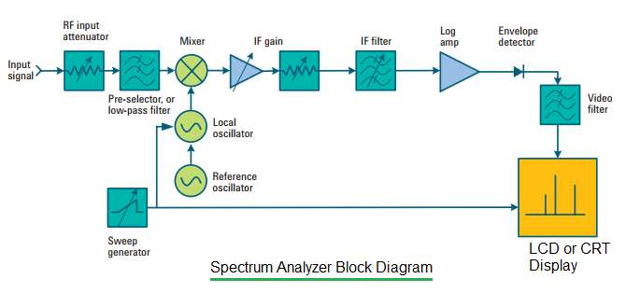It's is used for measurement of **radio frequency signals** in **microwave** and **other frequency bands**. This type of spectrum analyzer plots microwave signal in X-Y co-ordinates, X-axis represents frequency (in Hz or MHz or GHz) and Y-axis represents power (in dB). It is basically a **frequency domain analysis tool**.

## Optical Spectrum Analyzer

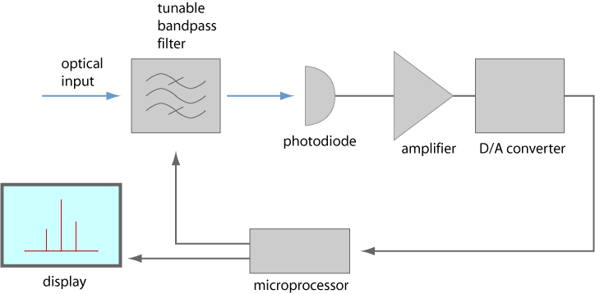It's is used for measurement of **optical signals** in **optical bands**. This type of spectrum analyzer plots optical signal in X-Y co-ordinates, X-axis represents wavelength (in µm or nm) and Y-axis represents amplitude or power (in dB).

## Microwave Spectrum Analyzer vs Optical Spectrum Analyzer

|  |  |  |
| --- | --- | --- |
| **Parameter** | **microwave spectrum analyzer** | **optical spectrum analyzer** |
| Measurement | Microwave signal | Optical signal |
| Plot dimensions | • X-axis:Frequency, • Y-axis:power(dB) | • X-axis:Wavelength, • Y-axis:power(dB) |
| Average Noise Level | • Non-zero average noise level • It is determined by RBW • Width of noise is determined by VBW | • Zero average noise level • It does not depend on RBW. • RMS level of noise is determined by VBW. |
| Sensitivity | Here it is defined as average noise level. | Here is is equivalent to six times that of rms value of noise. |
| Detector Type | Simple diode-based envelope detector | Photodiode based detector |

# Resources:

* RP-PHOTONOICS: Optical Spectrum Analyzers

<https://www.rp-photonics.com/optical_spectrum_analyzers.html>

* RF Wireless World:
* Optical Spectrum Analyzer basics: <https://www.rfwireless-world.com/Terminology/Optical-Spectrum-Analyzer-basics.html>
* Difference between Optical Spectrum Analyzer and Microwave Spectrum Analyzer: <https://www.rfwireless-world.com/Terminology/Difference-between-Optical-Spectrum-Analyzer-and-Microwave-Spectrum-Analyzer.html>
* YOKOGAWA: Optical Spectrum Analyzer <https://tmi.yokogawa.com/eu/solutions/products/optical-measuring-instruments/optical-spectrum-analyzer/#Resources_White-Papers>